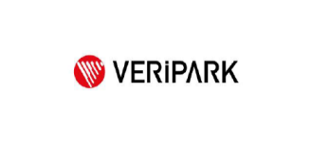

**VERİPARK INTERN**

**ÜRÜN YÖNETİM PROJESİ**

**REPORT**

**By**

**Mert Düver Lead by Çağatay ŞAHİN Efecan ÇETİR**

**İzmir**

**23.09.2021**

# CHAPTER ONE

INTRODUCTION

This report has written for the presentation and the check of the project that requested from Mert Düver over the internship period of the VeriPark. The project is developing a web

application that lists and manages the products of a newly established food company.

# CHAPTER TWO

REQUIREMENTS

Requirements recevied as:

**CHAPTER THREE**

UML DIAGRAMS

**Sequence Diagram**

# CHAPTER FOUR

IMPLEMENTATION

**4.1. DataBase:**

Database has 1 table named as “Products” and it has 5 columns as specified at requirements section. As a database software Microsoft SQL server used in this project. Id column has set to auto increment.

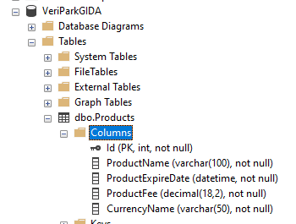

**4.2. Back-End Side**

In this project C# has used as back-end side. An ASP.NET Core Web API project has created from visual studio and used as well.

**Project Structure** is shown below:

-In the Controller class we have html methods, such as HttpGet, HttpPost, HttpPut, HttpDelete.

-In Product class we have model associated with the database.

-In the context class we have the connection between the database and the c#.

-In MyApi directory we have the front-end files and folders as an angular project.

-Startup class has the “Cors” settings an option to connect the project with the angular app.

**4.3. Front-End Side**

In this project Angular CLI is used as front-end. This angular project communicates with the C# codes and draws the web page and all its visual components. Routings and links are

also configured from angular. Angular project communicates with the back-end project via Cors connection and makes requests. Then shows the information to the user.

Bootstrap is used in the project in general.

The project consists of a couple of components, project structure can be shown below:

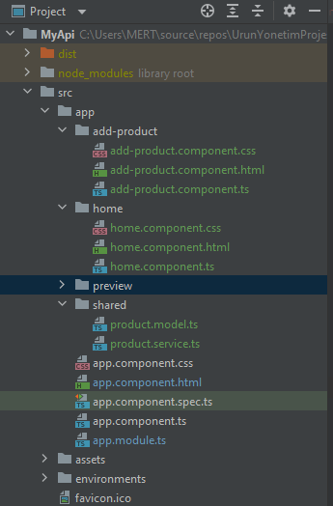

In here, as everyone can guess home component is our main component and it’s also the home page of our project. It has a navbar and the product listing table.

The blue selected preview component is not included to the project as the time because I couldn’t manage to it.

Routings:

# CHAPTER fıve

sCREEnSHOTS

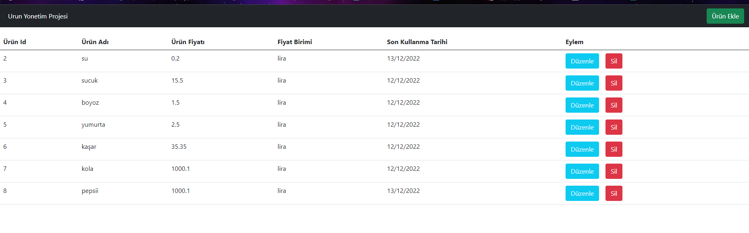

(Home Screen)

(Update Product Details)

(Product Adding Page)

# CHAPTER sıx

CONCLUSION AND FUTURE WORKS

In conclusion, the project has been completed almost with all the requirements. The project works fine and ready to use, develop, modify. It has a modular architecture. I started to learn web developing with this project and in the future, I will keep learning.

**Project Links**

<https://github.com/mertduver/UrunYonetimProjesi>

<https://github.com/mertduver/MyApi>

**References**

<https://angular.io/docs>

<https://www.youtube.com/playlist?list=PLZBLXQyhC0kpw_YK9hvak7HBCKmiFGVZW>

<https://www.pluralsight.com/courses/aspnet-web-api-building>

<https://app.pluralsight.com/library/courses/aspnet-web-api-building/table-of-contents>

<https://getbootstrap.com/>